iQ submit to order issue resolved

  - DEALER BULLETIN xx-20
  - June 2, 2020
  - Katie brekke, Sr Contact Services Manager

On Monday, June 1st, Andersen experienced an issue with the Submit to Order function in our iQ quoting tool. I am pleased to report we have resolved the issue and have a fix available. To implement this fix, download the iQ patch from andersenaccess.com and update your iQ tool following the steps below.

Once you have updated your system, return to using the Submit to Order process to place orders from iQ. If you have any questions, contact our Customer Service Team at 1-800-229-6091 for help.

instructions for downloading the iQ patch to update your iQ Software.

This fix will need to be done on each installation of iQ. If you run a centralized iQ platform these should most likely be done by your IT department.

- Log into Andersenaccess.com using your credentials

- Under the Quotes menu bar select Quote Software
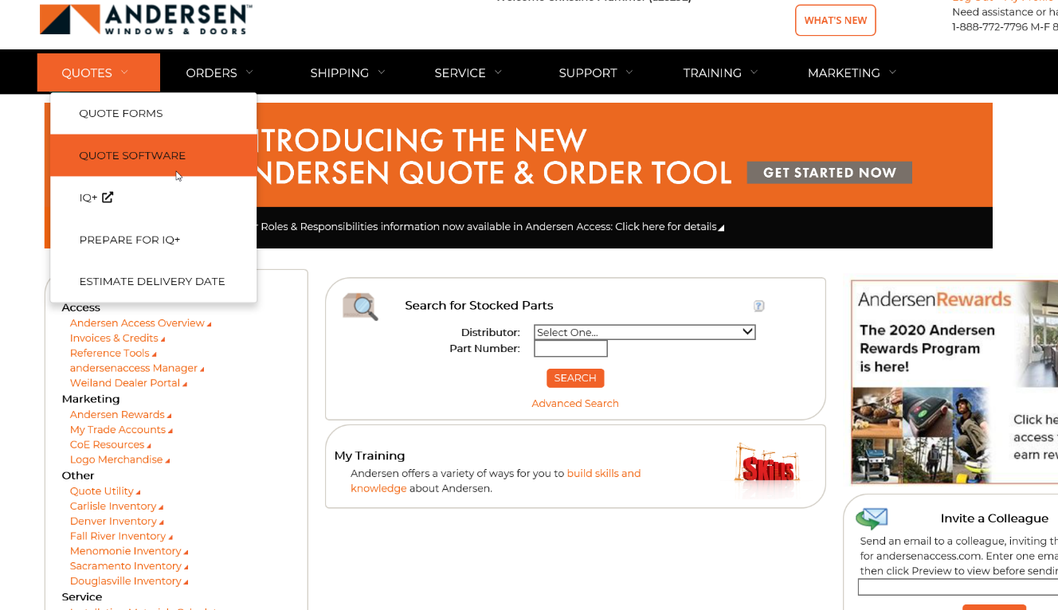

- Click on the 06-01-20 Dealer Patch link

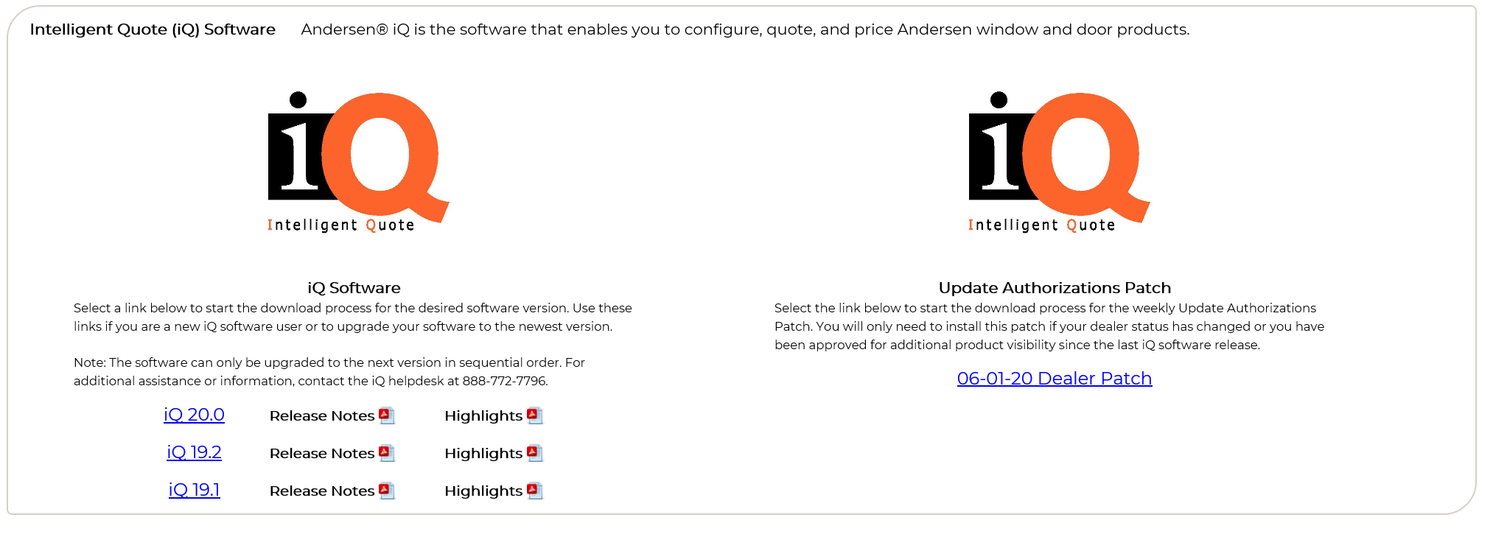

- Click the checkbox for the I have read and accept the installation instructions then click Continue Download

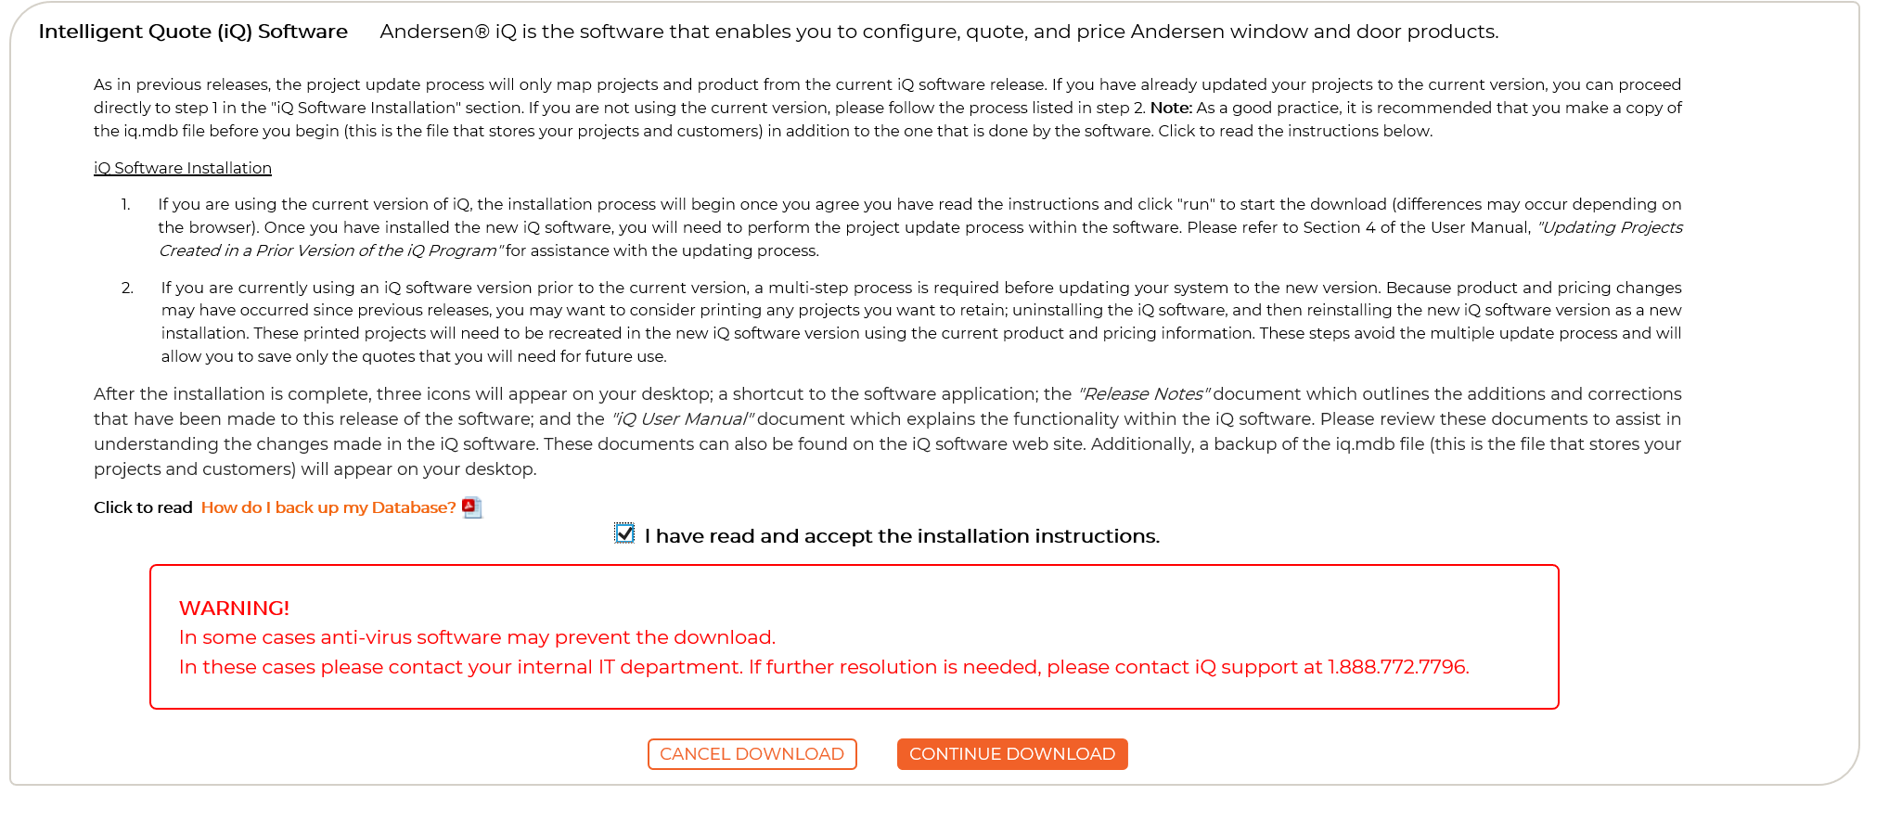

- The download will give the option where to save the downloaded file. By default, it will most likely go your Downloads folder. Once the download has completed click on the Complete Download button.

- Shutdown your iQ software if it isn’t already and locate the downloaded file and double-click on it, this will start the installation

- Click on Update to start the install and Finish when it has completed and then restart iQ
